- Define Instrument Type
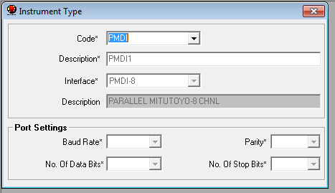
- Define Instrument of PMDISCL of type PMDI. Assign Port No.378, Check Display Cpk, Assign Cpk Port Number to send the signal ‘1’ and define Baud rate,Parity , Number of Databits and No, of Stop bits.

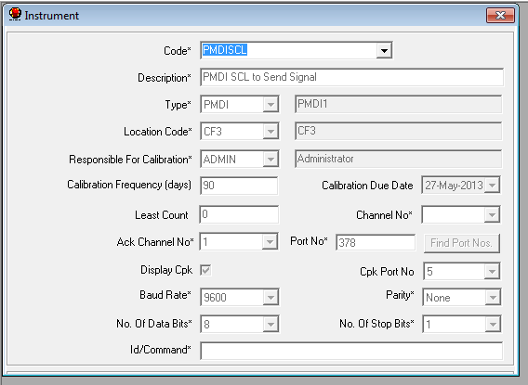

- In Configurable Parameter screen select Cp,Cpk for Value to be display on display board. i.e. Option->Settings->Configurable Parameters.

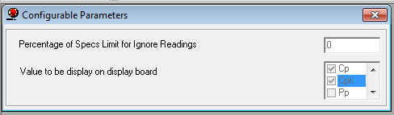

- In Measurement screen displayed – Date and Shift.
After completion of all parameter readings, application will send ‘1’ and Carriage return i.e. VbCr to the Port Number.

